November 2015

November 2015 dINNER Meeting
Main Program:
Stanford Energy Systems Innovations Project (SESI)
Speaker:
Colin S. Moyer, PE
Affiliated Engineers, Inc.
San Francisco, CA
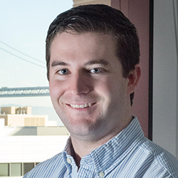
Mr. Moyer has advanced project experience in district energy systems with complex requirements. His responsibilities range from utility master planning with life cycle cost analysis, to demand side assessment and evaluation, to supply side design and optimization. His central plant design experience ranges from concept design through construction administration, commissioning, and operator training.
Presentation Summary
Stanford University’s commitment to reducing greenhouse gases produced on its campus was documented in the Stanford Energy and Climate Action Plan, for which AEI provided technical input. The long term goal was to establish a plan that minimized environmental impacts, increased efficiency and simplified maintenance and operations.
A major component of Stanford’s Energy Plan was to re-engineer its approach to thermal energy production in an effort to reduce carbon footprint, maximize energy efficiency, and reduce the use of non-renewable energy resources. This commitment required the decommissioning and replacement of a utility-scale combined heat and power cogeneration and steam distribution system. AEI analyzed several options, ranging from replacement of the obsolete CHP system to renovation of the existing CHP system to a new alternative approach with heat recovery chillers and ground source heat exchange. Options were evaluated based on capital costs, project energy costs and on-going maintenance and operations costs. Additionally, environmental impacts such as water consumption and carbon emissions were estimated and compared. Finally, a financial and energy risk analysis was completed as part of the effort.
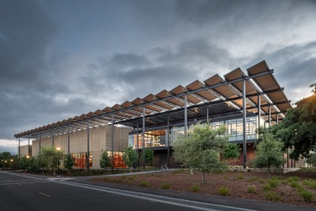
AEI served as the lead professional design entity for a completely new Central Energy Facility (CEF) and related hot water distribution for the campus, including building retrofits for conversion from steam to hot water. This extensive project involved the following components:
- Conversion of nearly 200 campus buildings from steam to hot water, including district energy heat exchangers at each building. This included an analysis of potential systems improvements in each building to maximize system delta-T and improve efficiency. The district hot water system was designed to serve both building thermal and domestic water heating loads, so, improvements in both systems were investigated.
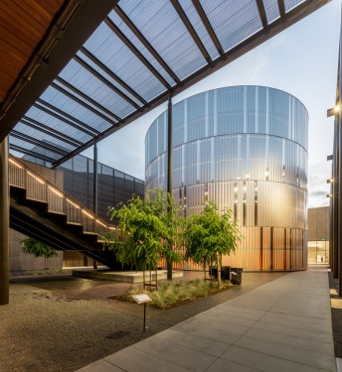
- A new central energy facility, the Stanford Energy Center, that is designed for a peak load of 28,000 tons of cooling and 350 mmbtu / hr heating. The plant utilizes a combination of heat recovery chillers, standard chillers and gas-fired hot water generators. One of the key elements of the system is the use of Thermal Energy Storage (TES) to reduce demand side impacts of high load periods. The system design utilized 10 million gallons of chilled water storage in two separate tanks for risk mitigation, plus 2 million gallons of hot water storage.
- New hot water piping from the CEF to the buildings. This involves over 20 miles of piping from the new CEF site to the various campus buildings. Several alternative hot water piping systems were investigated and analyzed and the system chosen was a direct buried, highly insulated, low loss piping system conforming to European Standard EN253.
- Interface with a ground source heat exchange system to enhance the operation of the heat recovery chiller. Heat absorbed by air-conditioning and other cooling systems on campus is transferred to the chilled water system and then subsequently rejected from the chillers at the OSHPD Plant into a new condenser water system.
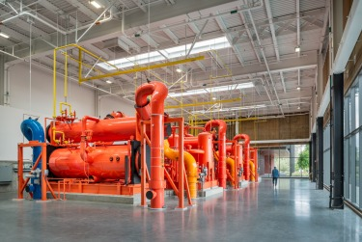
In Summary
- First of its kind Central Energy Facility
- Largest industrial grade heat recovery chillers in US
- 68% reduction in Campus Greenhouse Gas emissions (compared to Cardinal Cogen) by the end of 2016 after new solar energy contract is in place.
- 70% more efficient than the combined heat and power process provided by the previous cogeneration plant.

Thursday, Nov 12, 2015
5:30 PM to 8:30 PM
PG&E Pacific Energy Center
851 Howard Street
San Francisco
(415)973-2277
AGENDA
5:30 pm Registration and Social Hour
6:30 pm Dinner, Announcements and Introductions
7:30 pm Main Program
8:30 pm Adjourn
Register at www.ggashrae.org
COST:
GG ASHRAE Members
Before 5pm, Nov. 6 $40
After 5pm, Nov. 6 $50
Non-Members
Before 5pm, Nov. 6 $50
After 5pm, Nov. 6 $55
Students/Voucher Holder
Free, but please register

2015-2016 EVENT CALENDAR
Find details at ggashrae.org
Thursday, November 6, 8:00 am – 8:30pm
Inaugural YEA Technical Weekend
Location: Embassy Suites Buckhead
Topic: A weekend of high-performance building courses, technical tours, and networking
Thursday, November 12, 5:30pm – 8:30pm
Location: PEC
Topic: Stanford Energy Systems Innovations Project (SESI)
Speaker: Colin S. Moyer, PE
Thursday, December 10 (time to be announced)
Joint Meeting with San Jose Chapter
Location: (venue to be confirmed)
Topic: TBD
Speaker: Peter Rumsey
Thursday, January 14, 5:30pm – 8:30pm
Location: Oakland (venue TBD)
Topic: (Dinner Meeting TBD)
Speaker: TBD
Thursday, February 11, 11:30am – 1:30pm
Location: San Francisco (venue to be confirmed)
Topic: TBD
Speaker: Paula Kehoe
Thursday, March 10, 5:30pm – 8:30pm
Location: TBD, joint meeting with Redwood Empire
Topic: TBD
Speaker: TBD
Thursday, April 14, 5:30pm – 8:30pm
Location: San Francisco (venue to be confirmed)
Topic: TBD
Speaker: TBD
Thursday, May 12, 5:30pm – 8:30pm
Location, PG&E Pacific Energy Center
Topic: Awards and Product Show
Thursday, June 9, 5:30pm – 8:30pm
Location: (venue to be confirmed)
Topic: (Topic to be confirmed)
Speaker: Bill Bahnfleth

